**Adding an MS Azure Environment**

**Overview**

To add your MS Azure environment to Goliath, you will need the following:

* 1. Application (client) ID
  2. Secret ID
  3. Tenant ID
  4. Subscription ID

The following sections describe how to create and obtain the information above as well as how to add your environment to Goliath.

1. Create and register an App within your Azure subscription
2. Assign a Role to the newly created App
3. Create a new Certificate and Secret for the App
4. Add your environment to Goliath

**Create and register an App**

1. Within the Azure console, go to **Azure Active Directory >** **App registrations** and click **+ New registration.  
     
   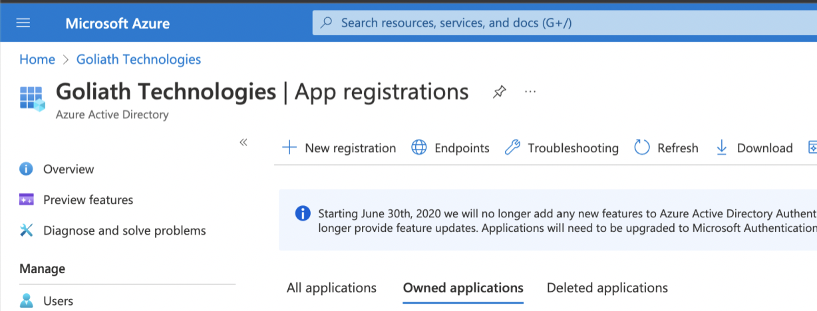**
2. Provide a name for the app, for example **goliathmcm** and leave the default, Single tenant option selected
3. Click **Register**.

**Assign a Role to the App**

1. Got to your subscription home page and click **Access Control (IAM).  
     
   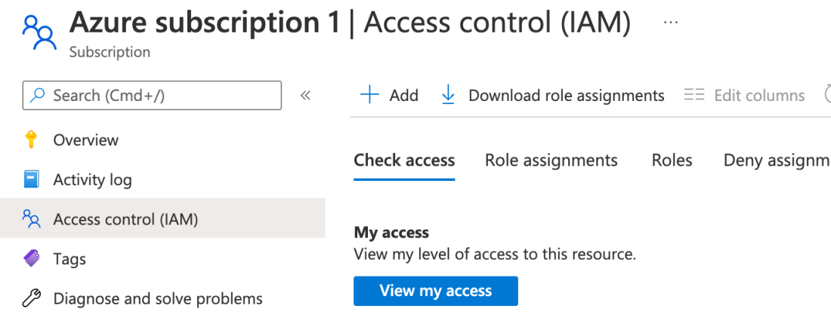**
2. Click **+ Add** then **Add role assignment  
     
   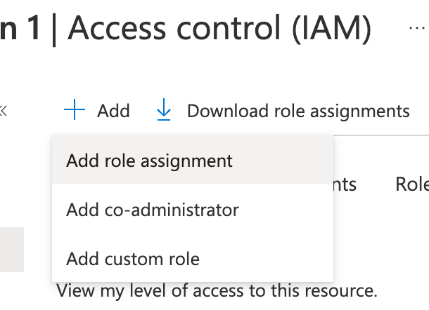**
3. In the **Role**section, select **Reader**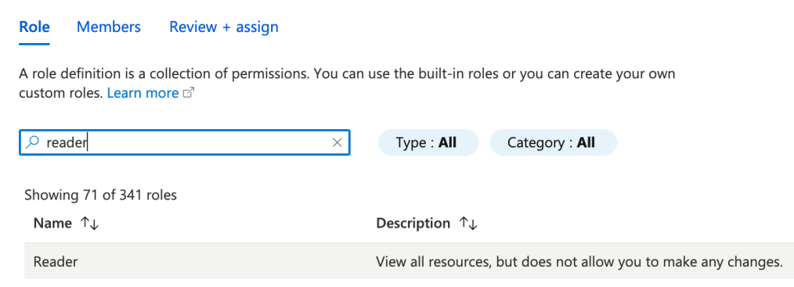
4. In the **Members**section, click **+ Select members** and find the app you created earlier from the dialog that opens.  
     
   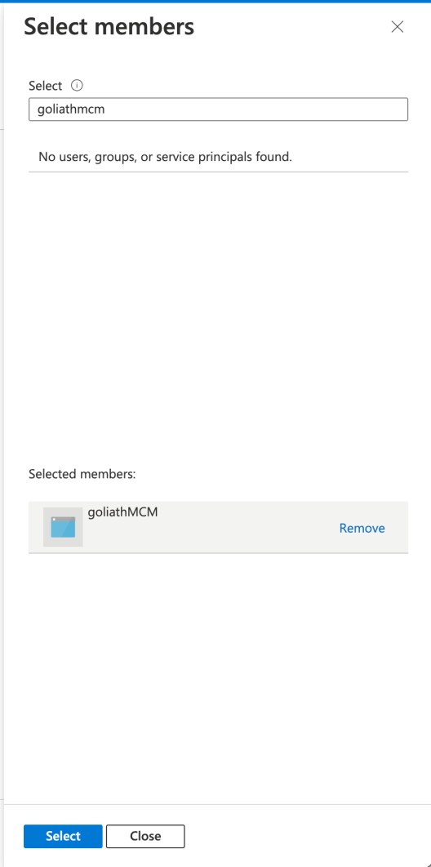
5. Click **Select**to select the app.
6. Back in the **Members**section, the app is added.
7. Click **Review + assign** to add the role.

**Create a new Certificate and Secret**

1. Within the Azure console, select **App** **registrations** then select the new app you created.  
     
   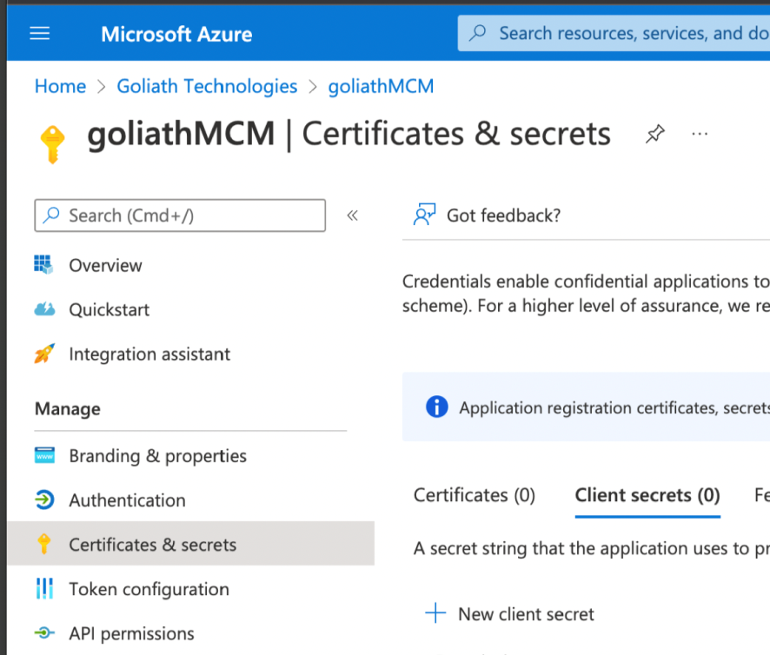
2. Click **+ New client secret**.
3. Provide a name for the secret and select an expiration time period and click **Create.  
     
   NOTE:** When a secret expires you will need to return to this step and create a new one, then update it within GMCM.

**Add the MS Azure Environment to the Goliath Cloud interface**

1. Go to [goliathapp.com](http://www.goliathapp.com)
2. Sign in with the credentials you were provided.
3. From the **Type**option, select **MS Azure**
4. In the **Add Environment** dialog that opens, enter a display name, for example "MS Azure"  
     
   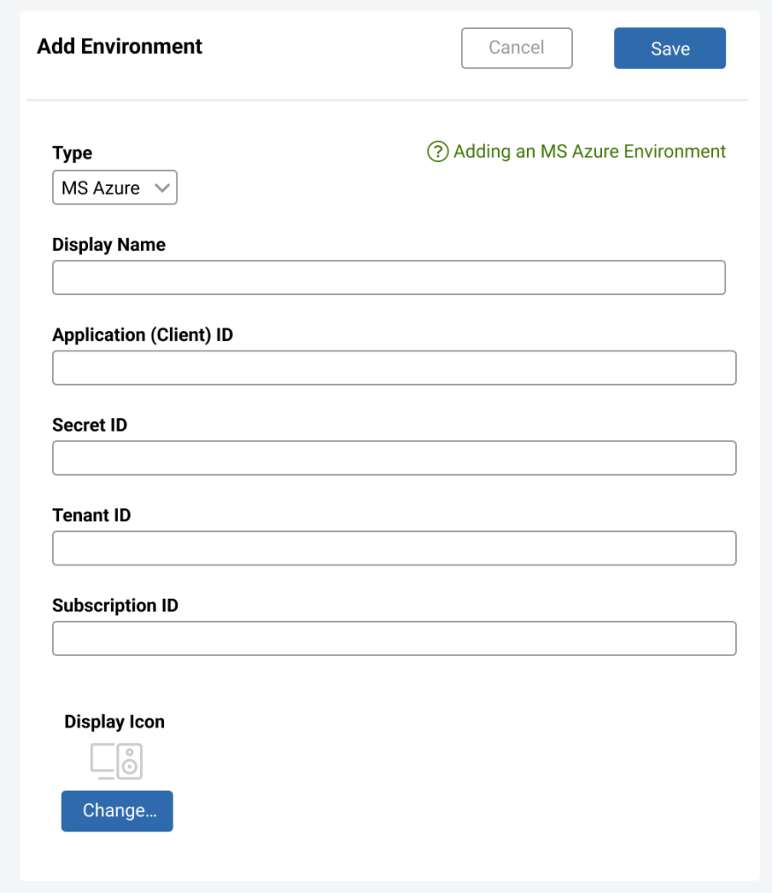
5. In the remaining fields, you will need to locate the details within the Azure console for the items you just created and enter them.
   * Application (client) ID
   * Secret ID
   * Tenant ID
   * Subscription ID
6. Optionally select a **Display Icon**.
7. Click **Save.**

The environment is added to the main menu on the left beneath an MS Azure parent menu object. Data will begin to populate the dashboards within a few minutes.

You can customize what is displayed on each dashboard by clicking the menu in the top right and selecting **Customize** **Widgets**.